LISTENING UNIT 4: TIME
- METHODOLOGY
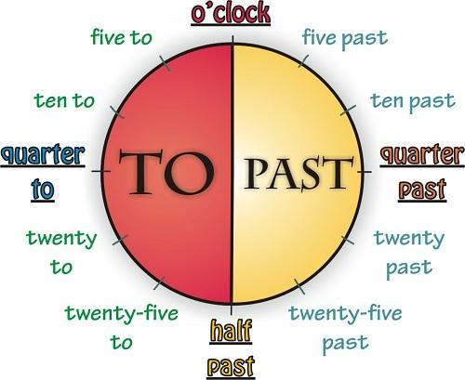
- Giờ chẵn: Giờ + o’clock/a.m./p.m.
Eg: I go to school at 7 o’clock
She wakes up at 7 a.m.
- Giờ lẻ: Giờ + phút
10:24 => Ten: twenty-four
10:10 => Ten: ten
- Giờ rưỡi: Half past + giờ
7:30 => Half past seven
11:30 => Half past eleven
- Giờ hơn: Phút + PAST + giờ
8: 25 => Twenty-five past 8
12:10 => Ten past twelve
- Giờ kém: Phút + TO + giờ
9:35 => Twenty-five to ten
6:50 => Ten to seven
- Giờ hơn 15 phút: A quarter past + giờ
Giờ kém 15 phút: A quarter to + giờ
9:15 => A quarter past nine
8:45 => A quarter to nine
- APPROACH
Exercise 1. (CD19) Can you tell me the time?
Listen to the recording and write down the times.
1. Excuse me. Can you tell me the "me, please?
Yes, it's 2h45……………………………………
2. Do you have the right time, please?
I think it's 1h30…………………………………
3. Do you know what time the next train to Leeds is, please?
Yes, it's 3h40……………………………………
4. When do the banks open, please?
At 9…………………………………………….
5. What time does the film finish, please?
7h20……………………………………………….
6. When did they come?
At 4h35…………………………………………….
7. What time do you finish your work today?
5h30………………………………………………..
8. Do you know when the play finishes?
Yes, at exactly.10h10..………………………………
9. Excuse me, please. What time does the Glasgow train arrive?
2h30…………………………………………..
10. When is the next flight to Paris?
11h40…………………………………………..
11. What time does the Oxford train arrive?
18h30…………………………………………..
12. When does the Tokyo flight leave?
19h40…………………………………………..
13. What's the next train to Liverpool?
5h10…………………………………………..
14. What time does the London train arrive?
7h20…………………………………………..
15. When does your mother come?
9h30…………………………………………..
16. When does the teacher come?
8h10…………………………………………..
Ex2. (CD20) What time does the next train arrive?
Look at the boxes below. Tick the appropriate times as you listen to the recording.
1.  14:14  14:40 V | 2.  12:15 v  12:50
3.  16:13 V  16:30 | 4.  22:13  22:30 v
5.

18:14
18:40 | V

Ex3. (CD21) Daily schedules
You are going to hear a conversation between two friends. As you listen, write down some of the details in the right columns. You will need to write a time, or length of time, or a few words to describe the activities. Some of the items have already been completed.
Time | Activities
6:00 | Get up
7:00 - 9:00 | Work
9:30 | School
5:00-7:00 | Work
7:30 | Have supper
8:00 | Homework
9:30 - 11:30 | Watch tv
11:30 | bed

- SELF-PRACTICE (CD22)
Exercise 1
01 | A. 5h-6h | B. | 02 | A. | B.
03 | A. 13 aug | B. 9h40 | 04 | A. | B.
05 | A. | B. | 06 | A. | B.
07 | A. | B. | 08 | A. | B.

Exercise 2
- You have to catch a train at…4h45……………………………………………………… .
- He arrived at the office at…9h15………………………………………………………….
- The store will reopen on…may23…………………………………………………………..
- Let's meet at the station at……6h5………………………………………………………
- My date of birth is……dec9//1983……………………………………………………………….
- Our flight's departure was delayed until…midnight…………………………………………...
- I can have a meeting with you at…11h30………………………………………………….
- Why don't we meet for lunch at…noon………………………………………………….?
- The concert has been postponed until…July 6th………………………………………………
- The package will be delivered around…mid-day………………………………………………

